Project Design Phase-II
Technology Stack (Architecture & Stack)

Date | 12 July 2026
Project Name | Customer Registry – MERN Stack Complaint & Customer Management System
Maximum Marks | 4 Marks

Technical Architecture:
The Deliverable shall include the architectural diagram as below and the information as per the table1 & table 2
Example: Order processing during pandemics for offline mode
Reference: https://developer.ibm.com/patterns/ai-powered-backend-system-for-order-processing-during-pandemics/
The architecture below mirrors the Solution Architecture document: a React presentation tier, a Node.js/Express application tier, and a MongoDB Atlas data tier.

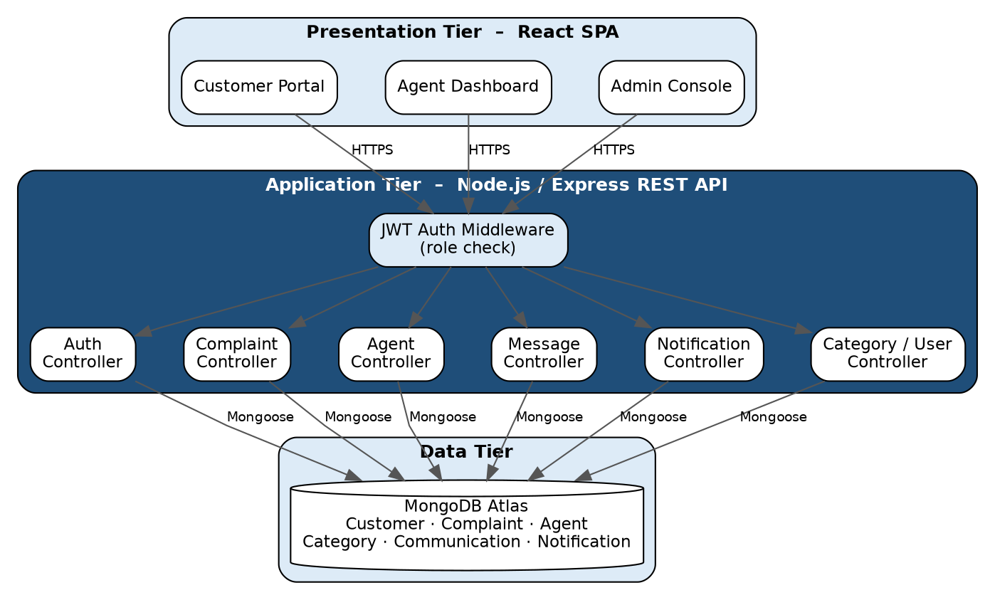
Table-1 : Components & Technologies:
S.No | Component | Description | Technology
1 | User Interface | React 18 SPA with role-based views for Customer, Agent and Admin | HTML, CSS, JavaScript, React.js, Axios
2 | Application Logic-1 (Auth) | User registration, login and JWT issuance; role-based route protection | Node.js, Express.js, jsonwebtoken, bcrypt
3 | Application Logic-2 (Complaint) | Complaint creation, status updates and history retrieval | Node.js, Express.js, Mongoose
4 | Application Logic-3 (Agent & Category) | Agent-to-complaint assignment and category management | Node.js, Express.js, Mongoose
5 | Database | Persistent storage for customers, complaints, agents, categories, messages and notifications | MongoDB, Mongoose ODM
6 | Cloud Database | Managed, replicated database with automatic backups | MongoDB Atlas (cloud-hosted)
7 | File System | Environment configuration and static asset storage | dotenv; local filesystem (server); public/ folder (client)
8 | External API-1 | Not used in the current release; parked for a future email-notification feature | Nodemailer / SMTP (future scope)
9 | External API-2 | Not used in the current release | –
10 | Machine Learning Model | Not used – no ML component in this release | –
11 | Infrastructure (Server / Cloud) | Local Node server for development; cloud hosting for production deployment | Local server; Render / Vercel / Railway

S.No | Characteristics | Description | Technology
1 | Open-Source Frameworks | All core frameworks are open-source and used under permissive licenses | React, Express, Mongoose, JWT, bcrypt
2 | Security Implementations | Passwords hashed with bcrypt; JWT-based stateless auth; role checks in middleware; protected routes on both client and server | bcrypt, JWT, Express middleware
3 | Scalable Architecture | 3-tier architecture (client / API / database) lets each tier scale independently; the stateless API supports horizontal scaling | React + Node/Express + MongoDB Atlas
4 | Availability | Stateless API can run as multiple instances behind a load balancer; MongoDB Atlas offers managed replication and failover | Load-balancer-ready Node API; MongoDB Atlas replica set
5 | Performance | Resource-scoped REST endpoints avoid over-fetching; Mongoose queries are filtered by agent/customer id rather than scanning full collections | Lean JSON payloads; indexed Mongoose queries

